QUERIES FROM 9 T0 18

**9.Query to display Name and Hire Date of every Employee who was hired in 1981.**

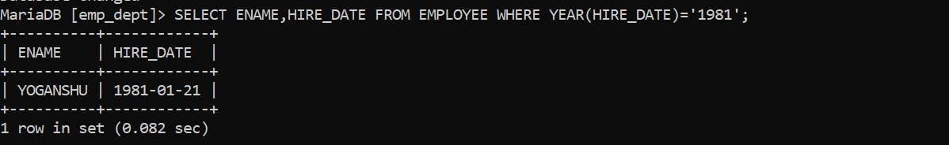

**10. Query to display Name and Job of all employees who have not assigned a supervisor.**



**11. Query to display the Name, Salary and Commission for all the employees who earn commission.**

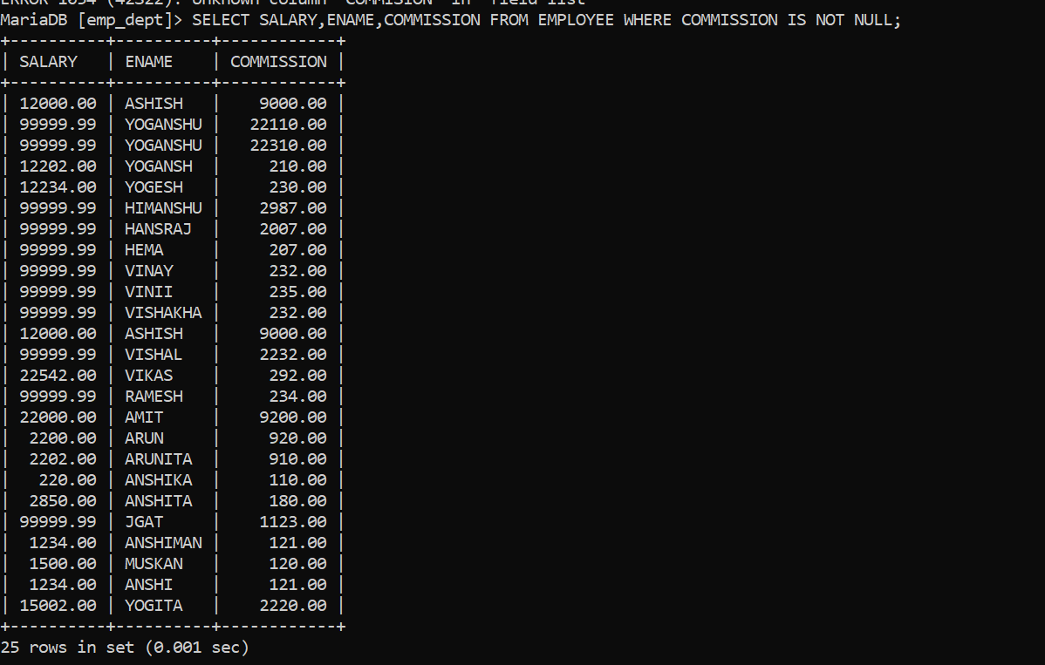

**12. Sort the data in descending order of Salary and Commission.**

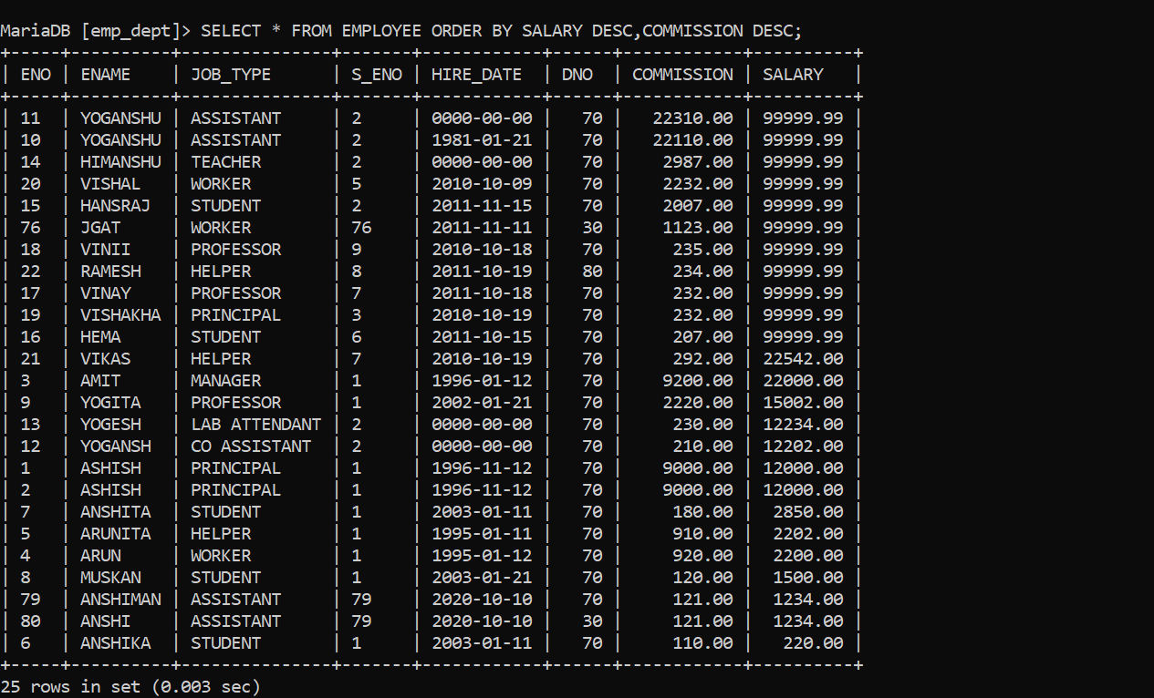

**13. Query to display Name of all the employees where the third letter of their name is ‘A’.**

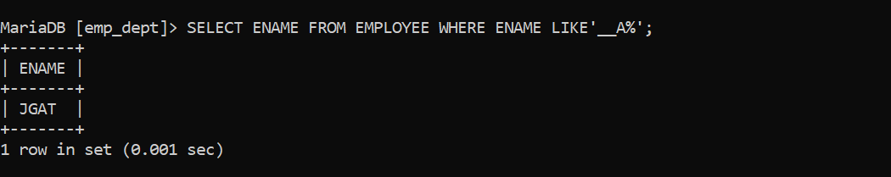

**14. Query to display Name of all employees either have two ‘R’s or have two ‘A’s in their name and are either in Dept No=30 or their Manager's Employee No=7788.**



**15. Query to display Name, Salary and Commission for all employees whose Commission amount is greater than their Salary increased by 5%.**

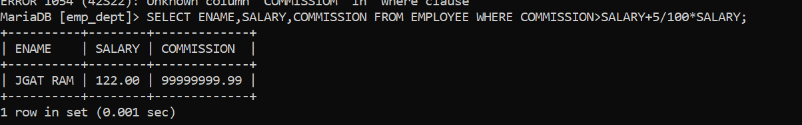

**16. Query to display the Current Date along with the day name.**

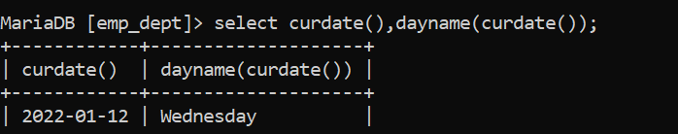

**17. Query to display Name, Hire Date and Salary Review Date which is the 1st Monday after**

**six months of employment.**

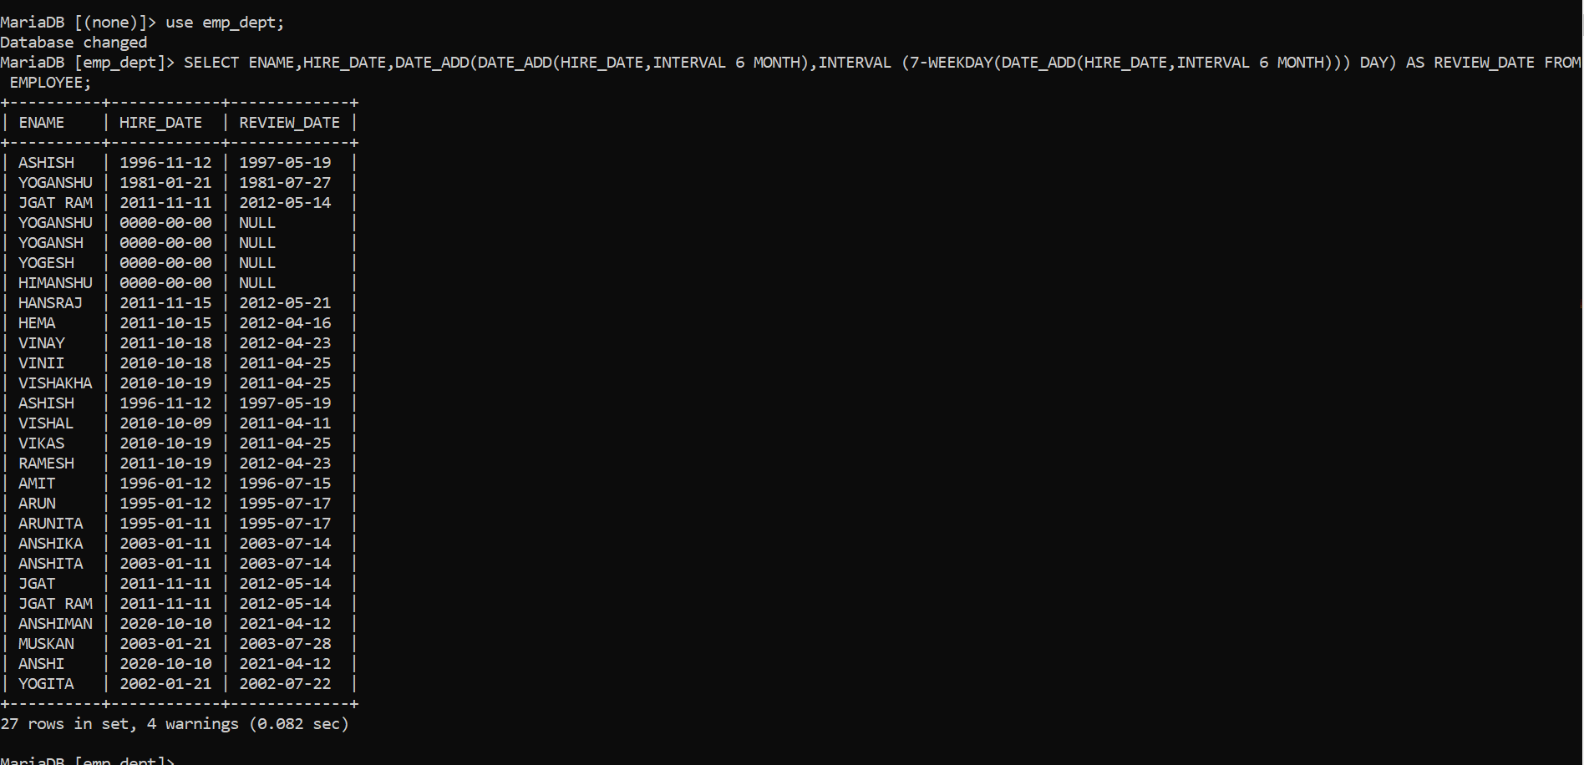

**18. Query to display Name and calculate the number of months between today and the date**

**on which employee was hired of department ‘Purchase’.**

